Parrot Traing by Rabindranath Tagore

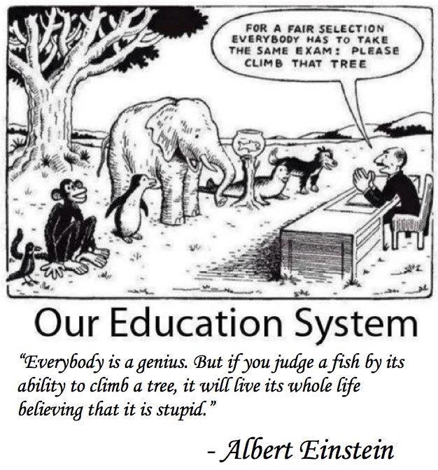

[It is a well established truth that Education is the Backbone of a nation and Children are Future of that nation. So, Child Education is very important for the progress of a society. Rabindranath expressed his thought on our Education system which I find very much relevant still today]

**TOTA KAHINI (Story of a Parrot)** by Rabindranath Thakur

1

There was a Bird.

It was illiterate. It was used to sing but never read scriptures. It liked to jump, fly but never cared for custom and convention.

The King proclaimed, “Such a bird is good for nothing but eating fruits it makes loss in my fruit market.”

So he called his Mantri (minister) and said “Teach the Bird”

2

The responsibility to teach the Bird was given to the Nephews of the King.

Great scholars came and discussed a lot.

The question was: What is the reason behind the ignorance of this creature!

After lot of brain storming they decided: The nest, which the Bird makes by useless hays and twigs, is so small that it can’t contain enough knowledge. So, first of all it needs a good cage.

The Kings pet scholars got lots of gifts and went away.

3

The goldsmith came to make the cage.

He made it so beautiful that people rushed to have a look at it. Many of them said “great endeavour for education”. Some other said “even if it can’t learn, at least has got a cage so nice. Very lucky bird”

The Goldsmith got huge fees and went away.

Now Pandits arrived to teach the Bird. Taking lot of pinches of snuff they said “It needs lots of scriptures”

The Nephew called the scripture writers. They started to make heaps of copies from manuscripts. And again they made copies from those. Everybody there said “Bravo! It’s a great heap of knowledge.”

So the writers got service charge full of their bullock carts. No more poverty remained for them.

The Nephews are always very much cautious for that costly cage; very much alert for timely maintenance, necessary repairing, cleaning and polishing it time to time. Everyone accepted “progress is very much satisfactory”

Hundreds of people were engaged for the project. Double of them were there for vigilance. All of them as well as there brotherly subsidiaries became rich getting fat envelopes of salaries.

4

Although there are shortage of many things in life but there is no shortage of naggers in this world.

They said “Although beautification of cage is going well but nobody thinks about the Bird”

The criticism reached even up to the King. He enquired to his Nephews.

Nephews replied “ Sir, if you want to know the Truth, then call the Goldsmiths, call the Pundits, call maintenance and service people of the cage, call all of them and ask.............actually these poor naggers don’t get to eat enough there that is why they always criticize”

The King became very satisfied and understood very clearly so Nephews got thick gold chains.

5

Next, the King expressed his desire for a personal visit to have a look of the huge magnitude of this great project.

So, one day with all his ministers and officers he appeared at the door of Bird school. All the Drums, Trumpets, Bugles, Flutes, Bells etc. announced his arrival.

The Pundits (teachers) immediately started Mantra chanting at highest volume. The Nephew, with all his maternal, paternal, eaternal brothers shouted “Jay Maharaja........”

Nephew said “Sir Look, what a great arrangement”.

The King said “The sounds for teachings are also not small”

Nephew replied “Not only sounds, the meanings behind sounds also not small”

With pleasure seeing the whole arrangement, as the king turned back to ride on his Elephant, he heard the side talk of the Nagger “Oh King, have you looked at the Bird”

The King surprised in his self, “OMG! I totally forgot to see the Bird”

Again returned and told the Pundit “Let me have a look, how you teach the Bird”

The king saw. He became very pleased.

The technique is so much large and huge that the Bird is almost invisible and also unnecessary to look it at all. The King understood that there is no negligence in the project.

There is no fruit, no water for the bird but only lots of torn out pages of writings in the cage, being pushed and packed into the bird through its open beak by the tip of pen.

No singing, no shouting. What an astounding scene.

This time after his visit the King ordered his attendant to squeeze enough the ears of the nagger.

6

Day by day, the bird was being more civilized gentle as a half dead. Its guardians understood it a good progress. Still, because of its bad habit, the bird used to look towards the morning lights and flap its wings (very undesirable!). Even sometimes it tried to break wires of the cage by its weak beak.

The Guard said “what a bad motive it is!”

So the Blacksmith came with his hammer and fire arrangements. What a great hammering! They prepared the chain to bind the Bird and also clipped off the wings.

The relatives of king said with displeasure “In this country the birds are not only ignorant but also ungrateful”

Now the Pundits used to teach with pen in one hand and spear in other.

The wife of Blacksmith got necklace on her neck. The Guard also got special status.

7

The Bird died. When? Nobody noticed.

The worthless nagger dispersed the news widely.

The King called his nephew and asked “What is this!”

Nephew replied “Oh king, the Bird has completed all his lessons”

The king asked “Is the Bird still jumps restlessly?”

Nephew replied, “Not at all”

- “Still flaps its wings?”

- “No, never”

- “Again sings song?”

- “No”

- “Does it shout not getting fruits?”

-  “No”

The King said “Bring the Bird, let me have a look”

The Bird arrived. With it, the guards, the officers, horse riders also arrived.

The King pressed the Bird by finger. No sound, no movement, nothing. Only the pages of scriptures were Hushing inside it.

The new green leaves with their deep sigh were making the smooth breeze of spring heavy outside the Palace.